Antenna
# Source: Chatgpt (GPT-5-Mini) at [1/23/2026]
An antenna is a metal structure or component that transmits or receives electromagnetic waves, especially radio waves. It acts as the bridge between electrical signals and wireless signals in the air.
Think of an antenna as the ears and mouth of any wireless device — it lets devices talk to and listen from other devices wirelessly.

🔧 What Does an Antenna Do?
# Source: Chatgpt (GPT-5-Mini) at [1/23/2026]
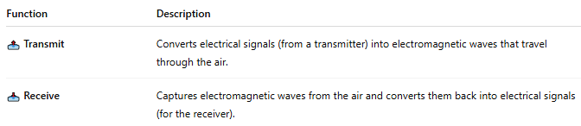

Function | Description
📤 Transmit | Converts electrical signals (from a transmitter) into electromagnetic waves that travel through the air.
📥 Receive | Captures electromagnetic waves from the air and converts them back into electrical signals (for the receiver).

🧩 Where Antennas Are Used:
# Source: Chatgpt (GPT-5-Mini) at [1/23/2026]
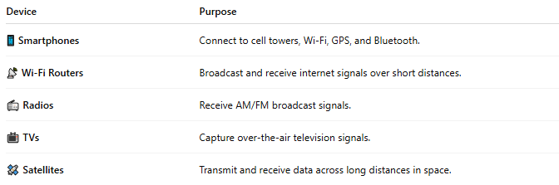

Device | Purpose
📱 Smartphones | Connect to cell towers, Wi-Fi, GPS, and Bluetooth.
📡 Wi-Fi Routers | Broadcast and receive internet signals over short distances.
📻 Radios | Receive AM/FM broadcast signals.
📺 TVs | Capture over-the-air television signals.
🛰️ Satellites | Transmit and receive data across long distances in space.

📐 Types of Antennas:
# Source: Chatgpt (GPT-5-Mini) at [1/23/2026]
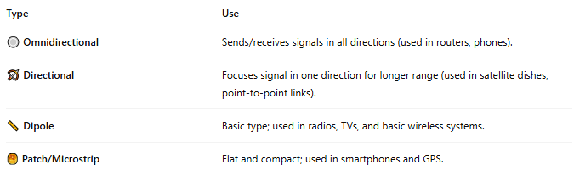

Type | Use
🔘 Omnidirectional | Sends/receives signals in all directions (used in routers, phones).
🏹 Directional | Focuses signal in one direction for longer range (used in satellite dishes, point-to-point links).
📏 Dipole | Basic type; used in radios, TVs, and basic wireless systems.
🥞 Patch/Microstrip | Flat and compact; used in smartphones and GPS.

⚙️ How It Works (Simple Flow):
# Source: Chatgpt (GPT-5-Mini) at [1/23/2026]
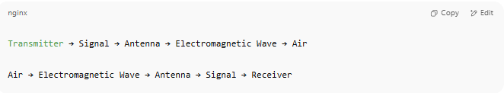

Transmitter → Signal → Antenna → Electromagnetic Wave → Air

Air → Electromagnetic Wave → Antenna → Signal → Receiver

The antenna radiates or detects electromagnetic waves to enable wireless communication.

📖 Summary:
# Source: Chatgpt (GPT-5-Mini) at [1/23/2026]
An antenna is a key component in any wireless system. It sends and receives radio waves, allowing devices to communicate without cables — essential for Wi-Fi, radio, mobile phones, GPS, Bluetooth, and more.

